Q1:

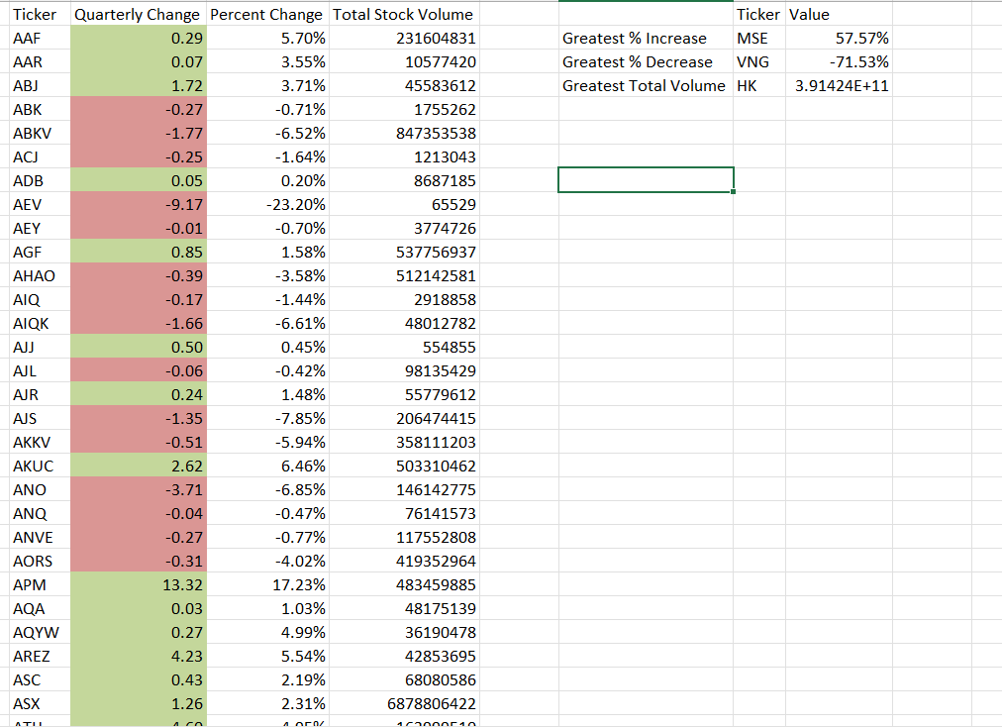Q2

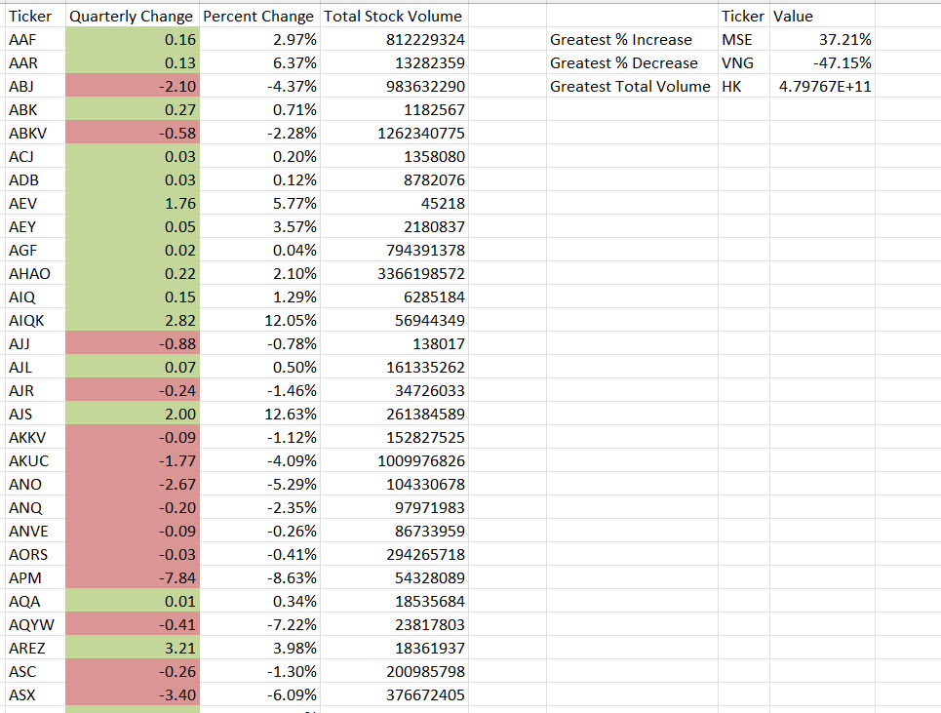Q3

Q4

